**RESTFUL API**

**What Is REST?**

REST stands for Representational State Transfer. It is a stateless software architecture that provides many underlying characteristics and protocols that govern the behavior of clients and servers.

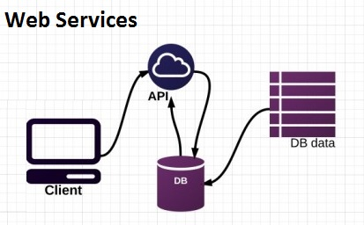

## What Is Meant by RESTful?

An API that has following features is known as RESTful API:

* **Client-server architecture**: The client is the front-end and the server is the back-end of the service. It is important to note that both of these entities are independent of each other.
* **Stateless**: No data should be stored on the server during the processing of the request transfer. The state of the session should be saved at the client’s end.
* **Cacheable**: The client should have the ability to store responses in a cache. This greatly improves the performance of the API.

## Why Use a RESTful API?

A RESTful API is used to make applications distributed and independent over the internet with the aim of enhancing the performance, scalability, simplicity, modifiability, visibility, portability, and reliability of the application.